Contents
OVERVIEW 3
PURPOSE 3
CONTACTS 3
DEFINITIONS 4
INTRODUCTION 4
ROLE OF PROCUREMENT SERVICES 5
Category Management 5
ETHICS 6
Conflict of Interest 6
DETERMINATION OF NEED / SELECTING A VENDOR 6
Preferred Vendors 6
USD Marketplace 7
Collaboration Requirements/Special Approvals 7
Freight Terms 7
Insurance Requirements 7
Supplier Diversity 8
Program Objectives 8
Sustainable Purchasing 8
Buy versus Lease 8
Export Controls 8
Restricted Vendors 8
COMPETITION AND CONDUCTING A BID 9
SOLE SOURCE 9
SIGNATURE AUTHORITY 10
CONTRACT REPOSITORY 10
Attaching a PO to an Existing Contract. 11
REQUISITIONS 12
Approvals/Workflow 12
Dispatching PO to Vendor 12
Receiving 12
A three way match 12
A two-way match 12
USD Marketplace (catalog) orders 12
USD Marketplace (non-catalog ) orders 13
Invoicing/Payment 13
Changes to Purchase Orders 13
Purchasing Items with the University Name or Logo 13
Vehicle Purchase 13
Internet Orders 13
Non-Purchase Order Transactions 14
REQUESTING A NEW SUPPLIER 14
Goods and Services Providers (Vendors/Suppliers): 14
Other Payees [Non Goods/Services Providers] 14
CONFIDENTIALITY AND POST AUDIT 15
Confidentiality 15
Post Audit 15
POLICY ENFORCEMENT/CONSEQUENCES. 16

OVERVIEW
The University of San Diego (USD) is subject to and complies with all applicable laws and regulations governing the purchase of goods and services. The University supports sustaining a procurement environment that allows departments and schools to determine what they need to run their programs. Purchasing Policy 2.10.2 along with these processes and procedures are meant to support their need to get products and services in a timely and cost effective manner, while also making sure appropriate business processes are followed and that the University complies with all applicable laws.
Procurement Services is considered the procurement expert at USD, setting the overall strategy regarding how purchases should be made and is the single point of contact for center-led purchases. Procurement Services consists of Vendor Management, Purchasing and Contracting, e-Procurement and Supplier Diversity.

PURPOSE
Considerable authority has been delegated to departments and schools to make purchasing decisions. This requires that employees involved at every step of the process take full responsibility for understanding USD’s policies and procedures regarding purchasing and contracting as well as vendor relations. Purchasing decisions are business decisions made on behalf of USD and therefore should be made with the utmost consideration for what is in the best interest of USD. Purchases also need to be made in the most efficient and cost effective manner. These procedures ensure that appropriate business processes occur when dealing with outside vendors. These procedures are meant to provide guidance to end users making purchases on behalf of USD.
Department and school personnel responsible for making purchases are expected to have appropriate security for their role (requestor, approver, etc.). They must also read and acknowledge the purchasing conflict of interest statement and attend any related training.

CONTACTS
If you have any questions regarding these procedures, you may contact Procurement Services by email: procurement@sandiego.edu or Tel: (619) 260-4204, or by using the contact list below.

Theresa Robinson Harris
Director, Procurement Services
Email: theresaharris@sandiego.edu
Tel (619) 260-7733

Ken Schaefer
Sourcing and Contracts Manager
Category Manager, Lab Services & Supplies/Auxiliary
Email: kennethschafer@sandiego.edu

Chris Shtino
Senior Procurement Agent
Category Manager, Facilities
Email: cshtino@sandiego.edu

Shirley Rosas
Procurement Agent
Email: srosas@sandiego.edu

Terry Magedman
Vendor Management Coordinator
Email: tmagedman@sandiego.edu

Conner Old
EProcurement Specialist
Email:cold@sandiego.edu

Liza Peterson Gary
Category Manager, IT/Telecommunications
Email: lizap@sandiego.edu

DEFINITIONS
AP – Accounts Payable
COI – Conflict of Interest
ITS – Information Technology Services
OGC – Office of the General Counsel
OneCard – Procurement Card/Purchasing Card
PO – Purchase Order
QRG – Quick Reference Guide
RFP – Request for Proposal
Unimarket – USD Marketplace
USD – University of San Diego

INTRODUCTION

USD’s goal with every purchasing transaction is to obtain the best value possible. USD strives to procure most goods and services through the use of contracts that have appropriate terms and conditions to properly protect the department/school, the University, and the vendor. When bids are required by policy, they are to be conducted on an open and competitive basis and without favoritism. Interested suppliers will receive fair and impartial consideration.

USD has implemented the Uniform Guidance Procurement Standards for all purchases. This is in accordance with government regulations 2 CFR 200.317-327. The primary goals of these procurement standards are to increase reuse of existing equipment and supplies, increase competition, and minimize sole source.

ROLE OF PROCUREMENT SERVICES
Procurement Services is the single point of contact for center-led procurement activities. Our role is to help departments/schools make informed, best value purchasing decisions consistent with applicable laws and guidelines, and to make sure products and services are paid for in the most streamlined way possible, as well as assist departments/schools with all other purchasing related issues. The primary responsibilities of Procurement Services are as follows:

Strategically source on behalf of the University by establishing contracts and agreements for use by all departments/schools based on formal, structured, and consistent processes.
- Actively review spend reports (including OneCard) to look for new contracting opportunities
- Conduct formal bid process/and or handle negotiations
- Develop contracts and secure appropriate signatures
- Streamline the ordering and payment process from contracted vendors
- Contract Administration:
  - Ensure compliance with applicable federal/state/local government laws
  - Promote USD-Wide contracts to the University community
  - Enforce requirements of the contract
  - Resolve disputes
  - Review and analyze prices and price increase requests
  - Discuss and document changes
Maintain, interpret and enforce purchasing policy
Approve purchases when central approval is required
  - Procurement Services reserves the right to review/question any purchasing transaction
Manage bid transactions over the Simplified Acquisition threshold of $250,000
Assist with the bid process on behalf of departments/schools
Manage the dispatching of Purchase Orders to vendors
Support and maintain the USD Marketplace
  - Manage the process of enabling new vendor catalogs
Process changes to Purchase Orders, when requested by departments/schools
Work with the Office of the General Counsel
- Make sure contracts, including terms and conditions, are appropriately reviewed
- Streamline the contract review process
Manage the Supplier Diversity Program
Vendor Onboarding and File Management

Category Management. In order to streamline purchasing Procurement Services has organized around several broad categories of spend: Lab/Scientific services and supplies, Facilities, Auxiliary, Events, Information Technology, and Travel. This is our strategic approach to segment purchasing into areas with similar or related products and services that enable opportunities for efficiency, savings, and consolidations. Each segment is managed by a Category Manager who is tasked with working at the department/school level to identify opportunities and coordinate procurement actions.

ETHICS

Ethical business standards shall govern all procurement transactions. Individuals making purchases on behalf of the University shall not solicit or accept a significant gift from a supplier or prospective supplier. A “significant gift” is defined as an item, service, favor, monies, credits, or discounts not available to others which could influence purchasing decisions.

Conflict of Interest (COI). Employees purchasing on behalf of the university must conduct each purchasing transaction in accordance with the highest ethical, legal, and moral standards. An employee must not be in a position to make a purchasing decision for the University if his or her personal, professional or economic interests (or those of his or her immediate and extended family member) may be directly influenced or affected by the outcome. A COI attestation may be required when requesting the addition of new vendors for purchases of $10,000 or more.

DETERMINATION OF NEED / SELECTING A VENDOR
When a department/school needs to purchase a product or service, there are numerous considerations that must be taken into account prior to selecting a vendor.
Preferred Vendors: Departments/schools should first check to see if a Campus-Wide Agreement or a Preferred Vendor Contract exists that they could use. Campus-Wide Agreements and Preferred Vendor Contracts are established by Procurement Services for products and services needed by USD departments/schools on a regular basis. Contracts are established as a result of a competitive bid/negotiation process that involves representatives from across the campus. Bidders determined to represent the best value to USD are awarded a Campus-Wide Agreement and become Preferred Vendors (based on price, delivery capabilities, quality, past performance, training, financial stability, ease of ordering, etc.). Departments/schools are strongly encouraged to utilize Campus-Wide Agreements and Preferred Vendors because they have been determined to represent the best overall value to USD. To find Campus-Wide Agreements see “Guided Buying” within the USD Marketplace.
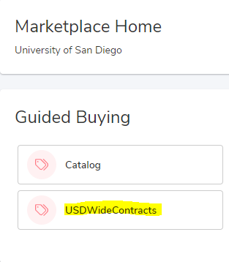
USD Marketplace: The USD Marketplace is a tool that was implemented to streamline the entire procure-to-pay process and should be used whenever possible. It provides end users with a web based ordering experience for many Campus-Wide Contracts and Preferred Vendors. It is also integrated with the Workday Financial System. USD Marketplace includes catalogs representing literally millions of items that may be needed on a day-to-day basis, all of which reflect competitive discounted pricing, often delivered within 1-2 business days at no additional cost. POs are dispatched electronically, invoices are received electronically, workflow is streamlined, and vendors are paid electronically. To get to the USD Marketplace, log into Workday Financials using your Single Sign On, then use the “Connect to Supplier Website” task under Menu to connect. Also see FAQs for USD Marketplace frequently asked questions.
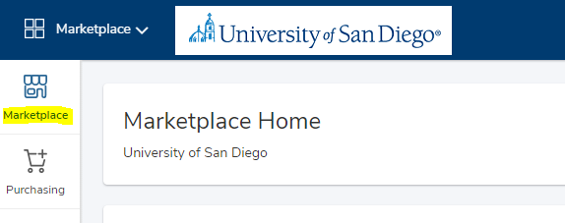
Collaboration Requirements/Special Approvals:
Departments/schools need special approvals for the following categories of goods and/or services. Most approvals are built in with the Workday workflow:
- ITS – Computers, Telecommunications and related goods and services
- University Design – Furniture and Design
- Facilities Management – Construction and related projects.
- Branding – University Marketing and Communications
- Food – Auxiliary Services
Freight Terms. F.O.B. destination is the USD standard delivery requirement, since it provides the most protection to the department/school and USD. F.O.B destination means that legal ownership of the item transfers when it reaches the buyer at the University. Therefore, the seller pays all shipping costs and is also responsible for the goods during transit.
Insurance Requirements. USD Risk Management has established minimum contractor liability insurance requirements for vendors conducting business with the University. Risk Management must review and approve any exceptions to the standard insurance requirements of USD. Procurement Services will coordinate the assessment of insurance coverage when handling the RFx process. See Competitive Bidding Requirements Quick Reference Guide for procurement thresholds.
Supplier Diversity. Procurement Services has created a Supplier Diversity Program to support the University’s Statement on Supplier Diversity. USD is committed to developing mutually beneficial relationships with small, minority-owned, women-owned, disadvantaged, veteran-owned, HUB-zone, and local business enterprises. The Program is managed by Procurement Services and is the University’s initiative to create opportunity for vendors reflecting economic and cultural diversity to market their products and services to USD, and encourage University departments/schools to offer opportunities to such vendors. Procurement Services maintains a list of diverse suppliers that are accessible through the USD Marketplace under Guided Buying.
Program Objectives:
- Present contracting opportunities to diverse vendors
- Develop partnerships between diverse vendors and University departments/schools that result in lasting business relationships
- Promote diversification of USD’s contractor base
- Maintain a high standard of quality in all products and services provided
- Comply with Federal, State, and Local government requirements regarding goals for small businesses
Sustainable Purchasing. Environmental impact should be considered in purchasing decisions. USD encourages departments/schools and individuals making purchasing decisions to familiarize themselves with our Sustainable Purchasing Guidelines and consider the use of products and services that do not cause significant impact to the environment. For Example, Single-use items such as K-Cups or Nespresso pods should be avoided. Reusable canisters should be preferred instead. Other things to consider are total cost of ownership, energy efficiency (Energy star equipment rating), shipping materials, landfill contribution, recycled content, waste prevention, waste reduction, pollution prevention, clean air and water programs, re-use of materials, minimization of scrap material, and any other green factory initiatives.
The University also maintains a surplus supply warehouse that offers gently used furniture and classroom supplies at no cost to the end user. See USD Sustainability for more information regarding USD’s climate plan and sustainable efforts.
Buy versus Lease. Equipment should almost always be acquired by outright purchase. Circumstances may require the leasing of equipment to satisfy specific needs. The economic benefits of leasing versus buying must be determined and documented before entering into any lease agreement. Third party leases are especially discouraged.
Export Controls. Vendors are responsible for complying with all applicable export control regulations. Any such export-controlled items, equipment, or information must be properly handled and labeled by the vendor. The vendor shall prevent such export-controlled information from being improperly disclosed to USD.
Restricted Vendors. Vendors can become debarred or suspended by the federal government, by a state or local government agency, or by USD. Some vendors are placed on a restricted parties list which would prevent the university from doing business with them. Departments/schools must first submit a supplier request to get the vendor approved and added to the Workday Financial System prior to placing an order for goods and services. See “Supplier Request QRG” for more information.
The procurement of certain covered telecommunications equipment and services must flow through the IT Category Manager to avoid the purchase of these equipment from restricted and/or unauthorized vendors.

COMPETITION AND CONDUCTING A BID
If there are no University-Wide Agreements or Preferred Vendor for the product or services needed, bids must be solicited from at least three (3) vendors for purchases over $10,000. This requirement is waived for catalog purchases through the USD Marketplace and purchases utilizing University-Wide Contracts. These contracts have been sourced in advance and are fully compliant with regulations and USD’s bid requirements.
Departments/schools may source and purchase up to $250,000 in goods and/or services at the departmental/school level following an authorized method of procurement. Purchases expected to exceed $250,000 must be coordinated by Procurement Services to ensure compliance with applicable laws and regulations and USD’s strategic objectives.
In addition, Procurement Services has considerable experience managing the purchasing process, key vendors in various industries, other customers (i.e. University contacts for references or possible joint purchasing opportunities), and methods for benchmarking prices to make sure USD is getting the best deal, group contracts available to USD, as well as other negotiated contracts. Procurement Services will also make sure the contract is appropriately reviewed by the OGC and signed by an authorized individual.
Please see our Competitive Bidding Requirements and Reference Guide for additional information.

SOLE SOURCE
If there is no ability to solicit multiple bids, departments/schools must demonstrate that the purchase from a particular vendor is sufficiently justified as a sole source. Sole source means that a single vendor is uniquely qualified to meet the department/schools procurement objectives. To be considered a sole source and be exempt from the bid process, one of the conditions on the Sole Source Justification Form must be met, specifically:
- The actual product or service needed is the only one that will meet the department/school’s requirements and it can only be purchased from one source, or one manufacturer or distributor.

- The product or service must match or be compatible with current equipment or services

SIGNATURE AUTHORITY
After completion of the sourcing process, and upon selection of a vendor, a contract may be necessary. Services over $1,000 typically require a contract. Contracts and agreements that need to be signed by USD must be sent to the Office of General Counsel (OGC) for review. The University’s Contract Review Process must be followed at all times for all purchases requiring a contract.

CONTRACT REPOSITORY

USD’s contract repository can be accessed from within Unimarket
Adding a Contract to the Repository. From the “Contracts” module within Unimarket select “Create Contract”, complete all the mandatory steps within the form, following the QRG, then select “Finish”.

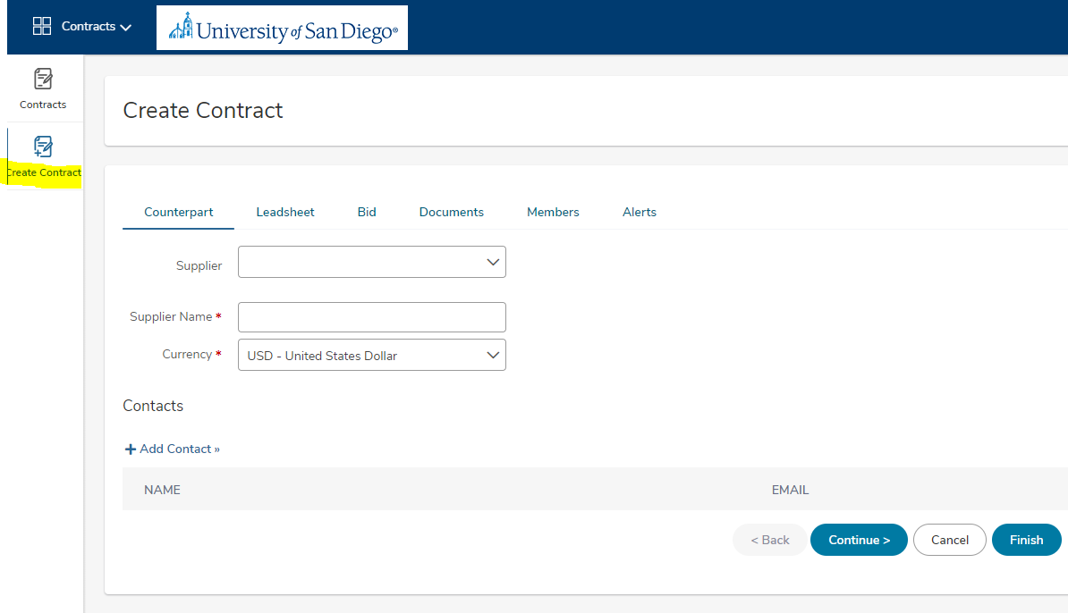

You may also review the “Quicklinks” under “Learning Center” for more detailed information on adding contracts.
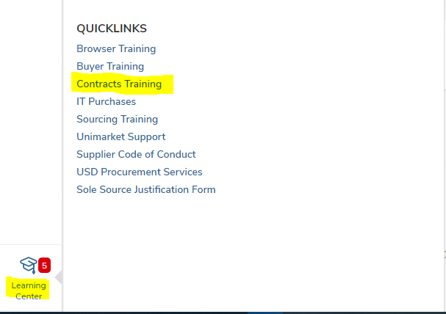

Attaching a PO to an Existing Contract.
From the USD Marketplace, select the supplier, then select “create” to add a non-catalog item to the cart, complete the form with all the required information, then select “add to cart” to complete the transaction. The contract will be applied to the PO issued to the vendor.
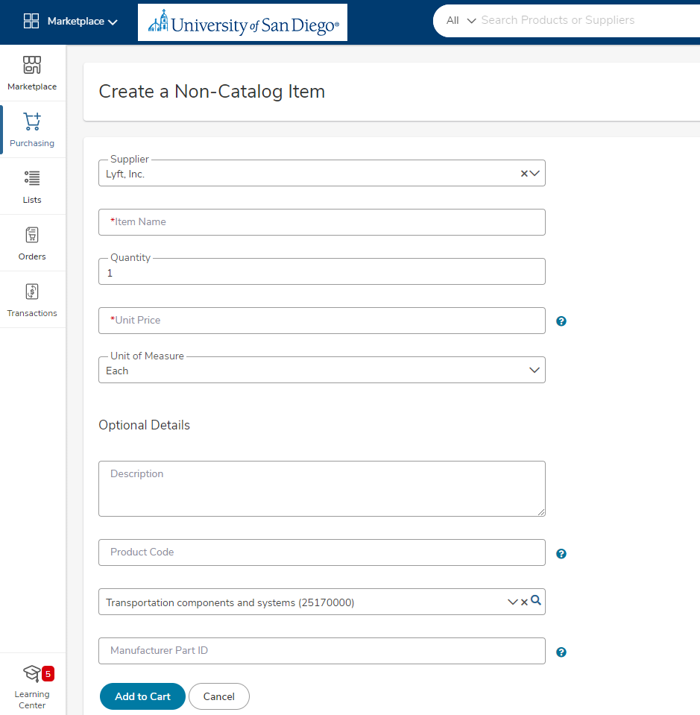

REQUISITIONS
The purchase of most goods and services from outside vendors begins by initiating a requisition in Workday Financials. This must occur at the time the product or service needs to be ordered, not when it is time to pay the vendor.
Starting with a Requisition ensures that an approved and official PO is issued. An official PO includes USD’s standard terms and conditions specifying each party’s rights and obligations, and is the legal document that governs the transaction and minimizes risks to the department/school and the University. It is especially important when there is no formal contract governing the purchase. Vendors need to agree to USD’s standard PO terms and conditions. If a vendor submits their standard terms and conditions with a quote, they must be reviewed and approved by the Office of General Counsel and Procurement before a PO is issued.
Approvals/Workflow. Requisitions typically require at least one approval. The approvals are obtained within Workday Financials. A PO will not be issued until all approvals have been received. Requisitions using Requisition Type “Unimarket” under $500 are auto-sourced. Requisitions between $500 and $5,000 must be approved by a “Mini Manager” (Gift, Grant, Project, Cost Center Manager, etc.). This streamlined approach helps to reduce the number of approvals required to get the PO issued to the vendor, which means that the goods or services can be ordered in a more timely and efficient manner.
Dispatching PO to Vendor. Once all approvals have been obtained, the PO will be issued and sent to the vendor immediately upon approval, based on the dispatch method identified in their vendor profile in Workday Financials (please note that most vendors included in Workday receive orders electronically).
Receiving. A Receipt is the department/school’s way of indicating that the product has been received or service has been provided and therefore the PO is approved for payment. To authorize payment, receipts must be entered as soon as possible after receiving the products or service. Please note that Unimarket orders under $500 will not require a receipt to authorize payment.
A three way match (PO, invoice, receipt) is required for most orders.
To authorize payment, receipt must be entered as soon as possible after receiving the product or service. A receipt should NOT be entered at the time the PO is issued prior to actually receiving the product or service as this may enable payment to the vendor prematurely.
A two-way match (PO, invoice) is required for the following:
USD Marketplace (catalog) orders. A receipt is not required for catalog orders placed through the USD Marketplace that are under $500 in order to streamline the payment process. The reason is because Procurement Services has a formal contractual relationship with these vendors that cover how things will be handled, which is enforced by Procurement Services. Procurement Services has leverage and the vendor has more incentive to perform as required by the Contract. Therefore, Procurement Services is in a much better position to resolve problems when they do arise. It is a more productive use of time to deal with the rare exceptions as opposed to requiring a receipt for every order placed through the USD Marketplace. If an invoice for a PO under $500 should not be paid, contact AP immediately to have the voucher put on hold.
USD Marketplace (non-catalog ) orders. It has been determined that a receipt is not required for non-catalog orders placed through the USD Marketplace that are less than $500 because they are very low risk transactions and this streamlines the payment process. If an invoice for a PO under $500 should not be paid, contact AP immediately to have the voucher put on hold.
Invoicing/Payment. USD may make a payment to a Supplier or to a Payee. Suppliers are paid to provide goods or services to the University. Payees are typically one time payments and may include those receiving a stipend, honorarium, reimbursement, students receiving payment for note taking, and those receiving a one-time gift or award,
A purchasing transaction is complete only after the goods or services have been received and the supplier has been paid. When a PO is issued, the department/school assumes responsibility to make sure the vendor is paid within an appropriate period of time. Vendors within the USD Marketplace will send electronic invoices back through the system to the person noted as the requester on the PO when the purchase is over $500. For purchases below $500 invoices are returned through the USD Marketplace and sent directly to AP for payment. If an invoice for a PO under $500 should not be paid, contact AP immediately to have the voucher put on hold.
Changes to Purchase Orders. Changes to POs that have already been sent to the vendor can be initiated by departments/schools by submitting a case through Salesforce. These change requests will be sent to Procurement Services for review and approval. Procurement Services will route certain requests through the same workflow that new requisitions go through when appropriate. PO changes will be sent to the vendor by Procurement Services after all approvals have been obtained.
Purchasing Items with the University Name or Logo. USD has exclusive rights to its name and logos and prohibits their unauthorized use. Vendors who manufacture and/or sell items imprinted with USD’s name or logo are required to be licensed. Licensee operate under specific guidelines; all products and designs must be approved in advance by USD’s University Marketing and Communications Department.
Vehicle Purchase. USD’s Vehicle Policy must be followed for the purchase of new vehicles, including on campus vehicles such as golf carts, etc. A Vehicle Purchase Request Form must be submitted to the Vehicle Review Committee prior to the purchase of any new vehicle. The Committee follows the Vehicle Review Committee Process to approve or deny requests for new vehicle purchase.
Internet Orders. Ordering via the internet presents increased risk and responsibility to those who transact University business with vendors over the internet who accept only credit-cards. Purchases over the internet should be minimized.
Non-Purchase Order Transactions. As stated earlier, the purchase of most goods and services from outside vendors is to be preceded by the issuance of an official PO generated by Workday Financials that is then sent to the vendor. However, we have identified some exemptions for certain transaction types that are considered low dollar and low risk, where a formal PO may not be as necessary. These include certain subscription services, journals, and professional memberships.

REQUESTING A NEW SUPPLIER
Most supplier requests will be for individuals and entities providing goods and services that the University will need to pay at a future date. There are other individuals however, who are not providing a product or service to the university, but will need to be set up for payment or reimbursement. This section covers how to submit a request to add these individuals to Workday Financials for payment.
Goods and Services Providers [Vendors/Suppliers]: Begin the request for a new supplier by submitting a Supplier Request through Unimarket. To do this, locate the “Connect to Supplier Website” app from your Menu within Workday Financials then complete the required information for the supplier by selecting “Purchasing” then “Supplier Request” from within the USD Marketplace.
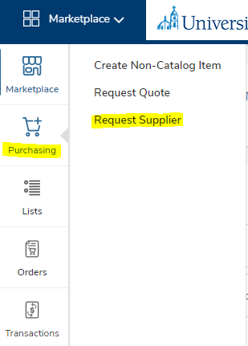
Procurement will review and approve the request then send an “invitation” to the supplier to self-register. When the registration is complete and all the pertinent information obtained from the supplier, the supplier is added to Workday Financials. Only at this time can the supplier be paid. Do not authorize a supplier to initiate work on any project until this step has been completed. The system will send an email when the supplier set up step has been completed. Only at this time is the supplier authorized to begin work. All suppliers must adhere to the University’s Supplier Code of Conduct.
Other Payees [Non Goods/Services Providers]: For those receiving a one-time payment or reimbursement, who are not providing goods or services (Students, awards, stipends, honorarium, etc.), use the “Create Supplier Request” task from within Workday and select the “Misc. Payee” supplier category to request set up of a new payee. Follow the instructions on this QRG to complete setup.
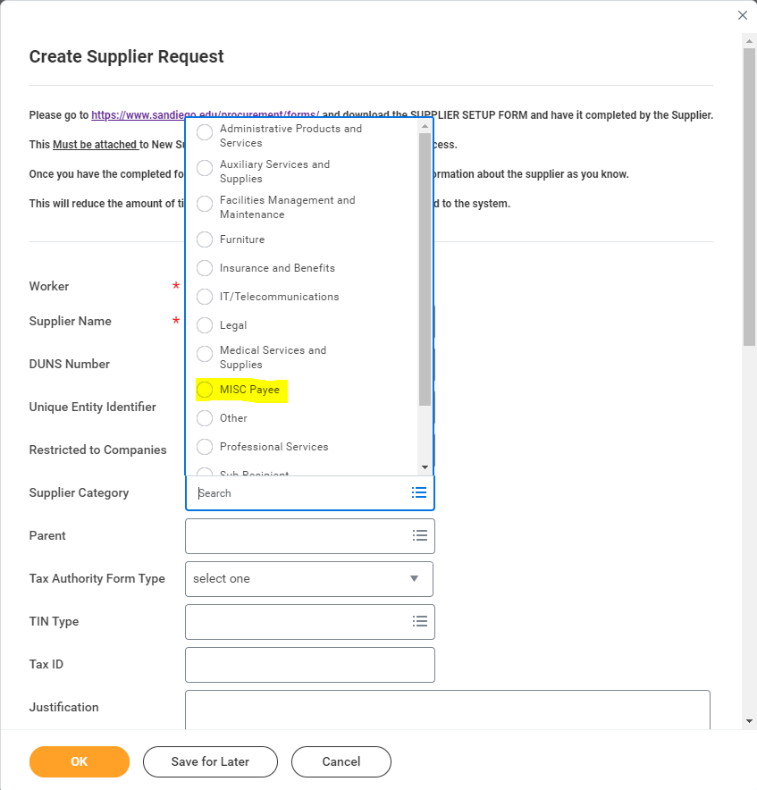

CONFIDENTIALITY AND POST AUDIT
Confidentiality. All information exchanged between a vendor and USD throughout the procurement to pay process is CONFIDENTIAL and shall remain the property of USD. No information (copies of bids, correspondence, contracts, etc.) is to be released to individuals or organizations outside of the University without the expressed permission of the Office of General Counsel and/or Procurement Services.
Post Audit. Procurement Services is responsible for enforcing purchasing guidelines. Periodically, Procurement Services will review reports of POs and Onecard transactions to look for new contracting opportunities, verify that guidelines are being followed, and to better assess when Preferred Vendors are not being utilized and why.

POLICY ENFORCEMENT/CONSEQUENCES.
Employees must be authorized to commit USD’s resources to a purchase. University faculty and staff are responsible for adherence to all sections of Purchasing Policy 2.10.2 as well as these guidelines. Examples of improper use of purchasing authority include:
- Stringing or splitting a large purchase into two or more smaller orders in order to avoid bid requirements and required approvals
- Conflict of interest and/or poor ethical conduct
- Not processing a purchase utilizing USD Marketplace and Workday Financials (Requisition to PO process)
- Bypassing Procurement Services for orders exceeding $250,000
- Improper, misleading, or deceptive use of the Sole Source Justification or any related information
Departments/schools, as well as individuals, may be subject to disciplinary action for failing to handle purchases according to policy and procedures. This may include:
- Restrictions on purchasing through the USD Marketplace for the individual and/or department
- Employee may be recommended for disciplinary actions to the appropriate Vice President, Supervisor, or through Human Resources

